APA Style Sixth Edition Template: The Biggest issue in cybersecurity is humans not machines.

Sahra Ali

Marymount University

Abstract

In the video *The Biggest Issue In cybersecurity is humans not machines,* Rachel Botsman explains the reasons why trust is the biggest key factor when it comes to cyber world. Her issue with trust itself came form a very young age. Her mother had to hire a babysitter for her at a very young age. The nanny ended up living with them. After 10months passed their nanny went missing for a couple of days. Rachel’s father went to their neighbors since the neighbor’s nanny and their nanny were good friends. To their surprise it turned out that both nannies’ ran a big drug business that was the biggest in north London at the time. Once they searched her room, they found a lot of things that were illegal. Few day’s after this discovery police end up knocking on their door to arrest their dad with the connection with armed robbery. She ended up using the father’s car which was used their silver van as the get away car. This story point’s out something important that is related to security.

*Keywords:* Rachel, trust, security, reliable, nanny.

Humans in cybersecurity.

Introduction:

This paper is about the importance in trust within the modern technology world.

We are living in a day where modern technology is advancing as the time passes. This also comes with trusting in random strangers without fully doing background check has its dangerous outcomes as well. Many people have died or went missing because they trusted a stranger that they just met online without fully doing a background search. Another technology tool that is popular that can be a breach of trust is Uber. Trusting a random stranger to not only give you rides but to also trust them with your home address is very critical. One other important aspect that Rachel mentioned is that “Money is the currency of actions, but Trust is the currency of interactions.”. Rachel also mentioned that now a day’s we are placing our trust in algorithms. Which is frightening but also true. Algorithms are making people want to trust everything and everyone very fast. The illusion of trust can lead to dangerous underestimated information.

One quote Rachel used that is very important to always remember is that *“Trust has two enemies, not just one: bad character and poor information.”*. Another very important question is “Is technology encouraging us to place our trust in the wrong hands of people and in wrong places?”. This question is very good question especially living in today’s day and age. We are living in a time period where technology is encouraging us to place our trust in random strangers that we have never met without fully analyzing who they really are.

One example will be online dating. This has become a very popular dating strategy. The most popular dating site is tender, eHarmony and many more. There are not only positive outcomes that are hopeful but there’s dangerous red flags regarding to everything about online dating. You do not automatically take your time in getting to know someone or do authentic background research on them. Instead, people want to do everything fast. They want to get to know someone today and meet them as soon as possible instead of taking percussion in fully getting to know the person and doing background/history research on them.

According to *backgrundchecks.org,* 10% of the sex offenders use dating sites. This is highly alarming since majority of the dating apps do not require background checks when making an account. Anyone can put fake name and pretend to be someone that they are not. According to *bachgroundchecks.org* it also states that 1 in 10 people who use online dating are scammers. Also, most sexual assaults are usually linked to online dating.

In today’s time period trust is flowing through platforms, networks and everywhere. This itself is dangerous and can be life threatening. While watching this video it makes more sense why the title is that the issue in cybersecurity is humans not machines. Humans we can be trustworthy and reduce the bad things that will happen. The algorithm can partner, set us up with a random stranger but at the end of the day it is a human’s choice whether that want to be reliable and make the world a safer place or be evil and cruel. Our actions as humans affect us more and more as technology advances and the modern world changes. Another good article that I came across is techbeacon.com. They touched on trust in the cybersecurity world. It touched on the different sites that you can and cannot trust. As well as had a whole section dedicated to being careful on whom you trust. If someone is out there in public platform or is interested in online dating, they should run up those two websites and read through them thoroughly.

Conclusion:

Personally, I consider myself to be well rounded as well as very careful on whom I trust in life. There are many people out there who claim they are someone good, nice but they turn out to be completely the opposite. I got into cybersecurity regarding to how now a day’s its so hard to find not only people but also websites that you can trust. It is good to be in a field where you know trust breach will not be coming from your classmates, professors, colleagues etc.

I am very big on social media, but I make sure not to accept strangers that I do not personally know. You must be careful regarding to the type of people you invite and let into your personal life. Just like the way Rachel said many of the times your issue is not with the algorithm it is with the human that you connected with. The type of person they are. Whether it is Uber/Lyft or online dating. It is always good to slow down and make sure you fully analyze the type of person you are inviting into your personal bubble. You must do background checks. This is also okay to stalk their social media and see what type of people they surround themselves with.

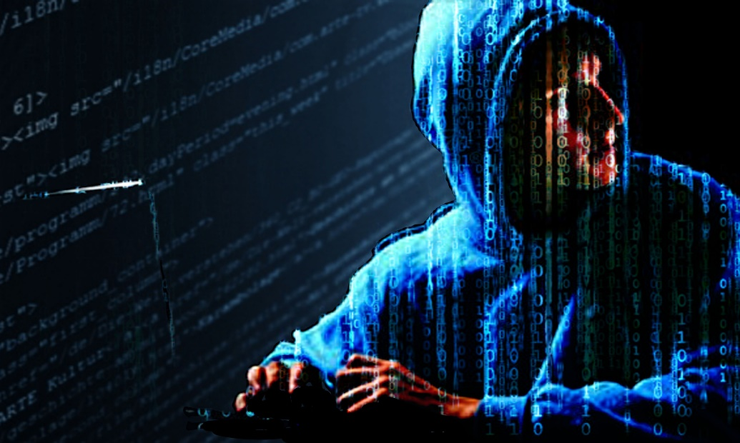

[This Photo](http://www.news.uct.ac.za/article/-2019-05-24-africa-first-for-ucts-cybersecurity) by Unknown Author is licensed under [CC BY-ND](https://creativecommons.org/licenses/by-nd/3.0/)

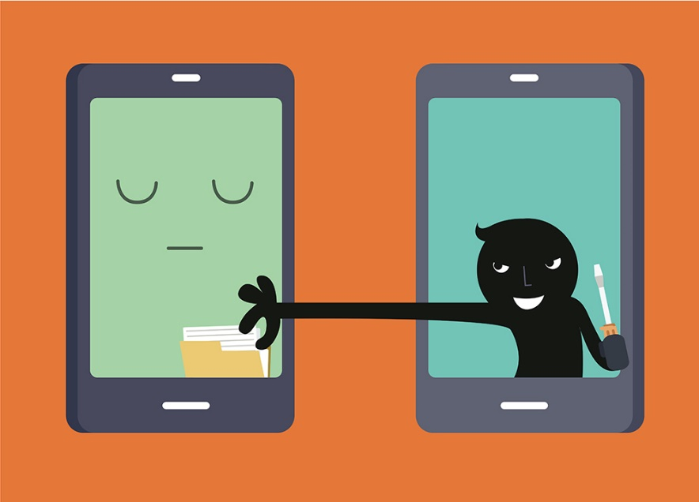

[This Photo](http://www.bauer-power.net/2016/07/protect-yourself-from-cyberthieves-when.html) by Unknown Author is licensed under [CC BY-SA-NC](https://creativecommons.org/licenses/by-nc-sa/3.0/)

References:

TechBeacon, Stan Wisseman, (2020). Broken Promises: How Trust affects cybersecurity

<https://techbeacon.com/security/broken-promises-how-trust-affects-cybersecurity>

Backgroundchecks.org, The Most Dangerous States for online dating

<https://backgroundchecks.org/the-most-dangerous-states-for-online-dating.html>

WiredUk, (April 4, 2018). The Biggest Issue in cybersecurity is humans, Not Machines.

<https://www.youtube.com/watch?v=15lS2SfW4pM>

**Both images from insert tab, Online pictures**